Online Event Management System

## **PROJECT OVERVIEW**

The Online Event Planning Website is a comprehensive web application designed to streamline the event planning process. This platform connects users looking to plan events with vendors offering event packages. Additionally, an admin panel is provided for managing vendors and user data.

This project is capable of providing all the important access to the admin and all the people related to a particular event. It gives the admin access to see user and the vendor list. Also, he/she will be able to create or delete a vendor and his/her corresponding package.

This project will reduce paperwork and manpower hence creating a hassle-free way of managing an event. Every even requirement will be traceable. One would be able to collect feedback from people and improve according to that feedback.

The purpose of creating this project is to digitalize the processes involved in an event, also it is easy to access so one can access it anytime and anywhere and perform a manage an event. It provides most of the basic functionality required by any event manager to smoothly run the event. This is to satisfy the needs of event manager as well as participants of event. They can enter their data and register for the event. This data is then sent to administrator which in turn can contact the participants.

Also this portal is designed keeping in mind several issues that are faced by event managers in executing any event successfully.

**Module description**

1. Admin: System administrators responsible for managing users, vendors, and the overall system. An admin can add, delete or edit vendor packages. He can also regulate the users that interact with vendors regarding particular packages.
2. Vendor: The vendor can login into their portal and add various packages and sell the plans to users according to their requirements.
3. User: The user can register into the portal if they aren’t existing user. User has the option to view profile, view the various available packages and choose amongst them, change the password and more.

**USE-CASE DIAGRAM**

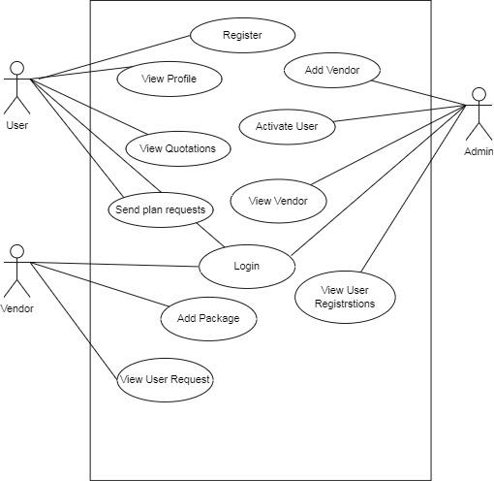

**ER DIAGRAM**

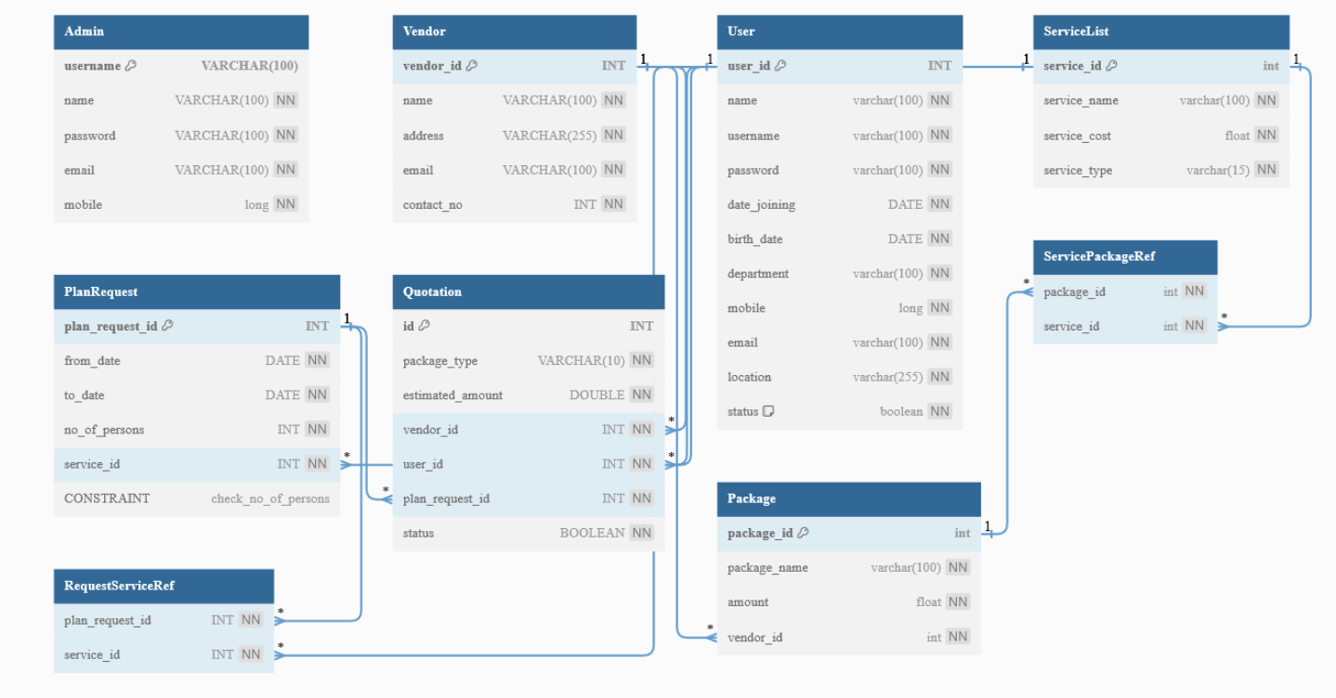

**DATA FLOW DIAGRAMS**

**ADMIN:**

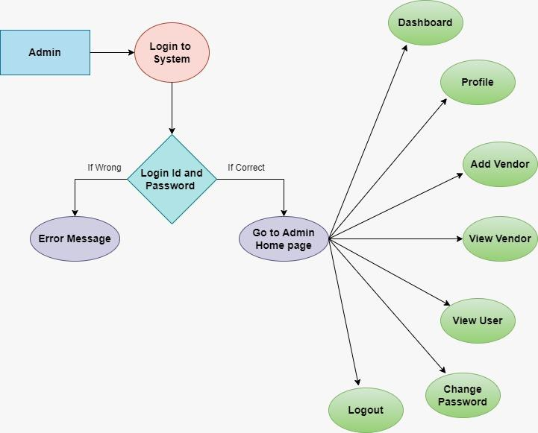

**USER:**

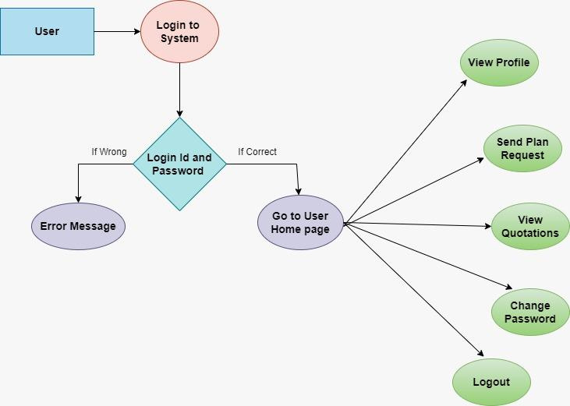

**VENDOR:**

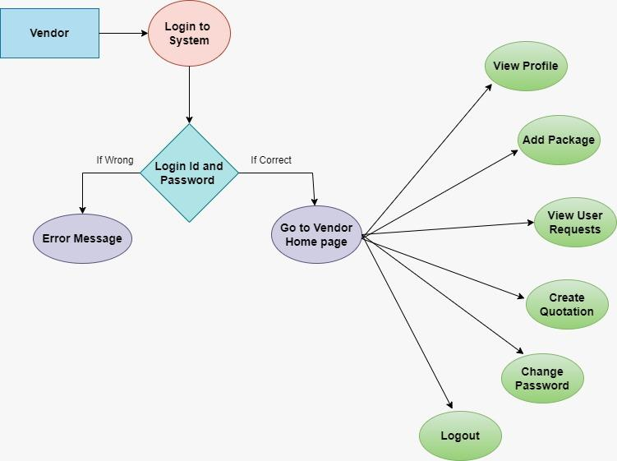

**Conclusion**

The Online Event Planning Website project aims to simplify the event planning process by connecting users with vendors. With a user-friendly interface, robust user and vendor management, secure payments, and an admin panel, this platform is designed to meet the needs of event planners and vendors alike. Future enhancements will further improve the user experience and functionality of the platform.